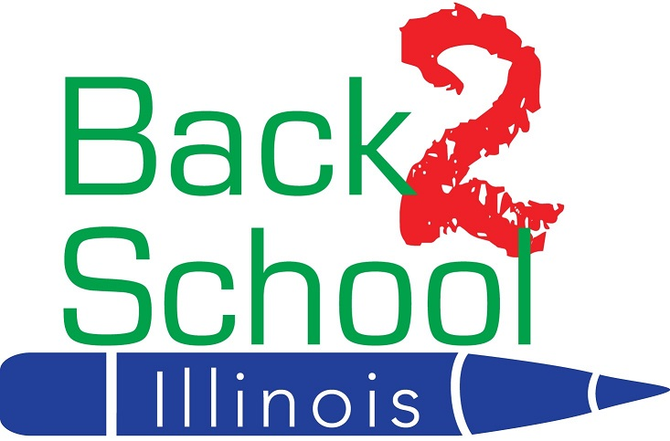

3959 N. Lincoln Avenue, Chicago, IL 60613 847.268.3550 (office/fax) info@B2SI.org www.B2SI.org

Back 2 School 2020 Program Launches
Help Us Raise Funds & Awareness

Dear Currency Exchange Owner/Store Manager:

The Back 2 School 2020 is about to get underway. You will be receiving the marketing materials later this week or early next week via UPS. Given the current situation with COVID-19, we are seeing a dramatic increase in the need for our Back 2 School kits. As a result, we are hoping you can help raise a record amount of dollars so we can assist more financially struggling families.

Inside the shipping tube you will find posters, along with several collection canisters, collection container labels, and teller window signs. In order to maximize the success of the program we ask you put up the posters and teller window signs immediately, put the labels on the canisters and have them placed on the inside of the cage, so customers can see them. The sooner you start collecting money, the more money your store will be able to donate to the cause.

Our experience in years past has been that stores with tellers that make a real effort to ask customers for spare change, raised significantly more money. In 2019 we raised $71,809. Our goal for this year is $80,000 so please encourage your tellers to encourage a donation.

Great News - The Western Union Foundation (WUF) is increasing their matching grant for 2020! We can earn up to $100,000 with your help. For every $2.00 collected they will donate a $1.00 to B2SI.

If you need additional posters, teller signs or collection canisters, contact the B2SI office at 847.268.3550 or email info@B2SI.org

We thank you for your continued support!

Regards,

Matthew Kurtzman
CEO

To create and support educational opportunities that enrich the lives of Illinois children

