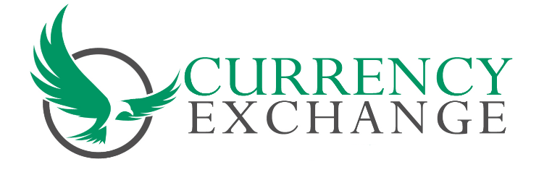March 23,2020
To all Currency Exchange Members and Employees
These next couple of weeks will be very important for us as owners and our employees. We are anticipating busy days. Please make sure you try to practice Social Distancing in your stores. Please keep the public as well as your employees safe. Let you customers know what your hours will be. Post signs to let people know what might be expected of them while they are in line. Please keep your stores and items in your lobby sanitized. People that have been quarantined may call for additional information. Seniors may be confused please go the extra mile to help our customers. This is a very unique time. The Governor and Mayor has considered us an essential business. Take pride in that an continue to be there for the community.

Sincerely
Jerry Tufano
CCEA President

